NHS No. | Name of Resident | Observations - (any you can do) |  | Any other concerns (soft signs) | DNACPR in  Place (Yes/No) | ReSPECT in place (Yes/No) | Date of last video call/GP visit
- Heart Rate/pulse
- Oxygen saturations
- Temperature
- Blood Pressure
- Respiratory Rate
- Heart Rate/pulse
- Oxygen saturations
- Temperature
- Blood Pressure
- Respiratory Rate
- Heart Rate/pulse
- Oxygen saturations
- Temperature
- Blood Pressure
- Respiratory Rate
- Heart Rate/pulse
- Oxygen saturations
- Temperature
- Blood Pressure
- Respiratory Rate
- Heart Rate/pulse
- Oxygen saturations
- Temperature
- Blood Pressure
- Respiratory Rate
- Heart Rate/pulse
- Oxygen saturations
- Temperature
- Blood Pressure
- Respiratory Rate
- Heart Rate/pulse
- Oxygen saturations
- Temperature
- Blood Pressure
- Respiratory Rate
- Heart Rate/pulse
- Oxygen saturations
- Temperature
- Blood Pressure
- Respiratory Rate
- Heart Rate/pulse
- Oxygen saturations
- Temperature
- Blood Pressure
- Respiratory Rate
- Heart Rate/pulse
- Oxygen saturations
- Temperature
- Blood Pressure
- Respiratory Rate
- Heart Rate/pulse
- Oxygen saturations
- Temperature
- Blood Pressure
- Respiratory Rate
- Heart Rate/pulse
- Oxygen saturations
- Temperature
- Blood Pressure
- Respiratory Rate
- Heart Rate/pulse
- Oxygen saturations
- Temperature
- Blood Pressure
- Respiratory Rate
- Heart Rate/pulse
- Oxygen saturations
- Temperature
- Blood Pressure
- Respiratory Rate
- Heart Rate/pulse
- Oxygen saturations
- Temperature
- Blood Pressure
- Respiratory Rate

How to use a Pulse oximeter
Follow these instructions to make sure the pulse oximeter gives an accurate reading:
- Remove any nail polish or false nails and make sure your resident’s hands are warm.
- Make sure your resident has been resting for at least five minutes before taking the measurement.
- Your resident’s hand should be resting on their chest at the level of the heart and held still.
- Switch the pulse oximeter on and place it on your resident’s finger. It works best on their middle or index finger (shown in the diagram).
- The reading takes time to steady. The pulse oximeter should be in place for at least a minute, or longer if the reading is not stable.
- Record the highest result once the reading has not changed for 5 seconds.
- Be careful to identify which reading is their heart rate and which is their oxygen level. A Guide to taking an oxygen saturation reading is available through this link https://www.youtube.com/watch?v=QabKghrtXps

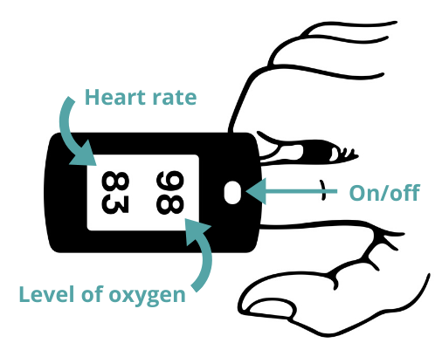
Recording and acting on the result
Write the information on the spread sheet.
Take extra measurements if you feel there is a change in your resident’s health.

