Smiling for life
Oral Health training for Care Homes

e Homes

The Community Dental Service’s Oral Health Improvement team is delighted to invite you to take part in the FREE Smiling for life, oral health training for care home staff.
Smiling for life programme
Mouth care is a CQC requirement that must be carried out in care homes. To support care homes meeting the requirements the Smiling for life training programme will:
Provide each nominated Oral Health Champion (preferably care home manager or deputy) with training resources and knowledge to cascade the training to their colleagues and help to implement national guidance to meet CQC requirements.

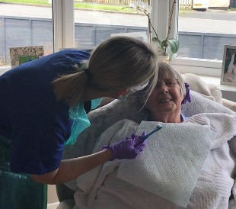

If you would like to nominate an Oral Health Champion for your care home to take part in the training, please complete the form on the following page and email to elisha.mistry@bdct.nhs.uk

Please complete each section and email to elisha.mistry@bdct.nhs.uk

Care Home name and address:

Size of care home: (number of residents)
Client group (e.g. LD, PD, older people, dementia):

Manager’s signature to confirm that: you will provide support; will release identified champion(s) below to attend training; and will contribute to the evaluation process:

Manager name and contact details:

Signature:
Date:

Champion (s) name:

Nominated Champion (s) email contact details:

Training on Microsoft Teams
Please highlight selected date or
Type below
…………………………………………….
Friday 1st of March 10am- 1pm | Wednesday 6th of March 1:30- 4:30pm
Thursday 7th of March 10am- 1pm | Friday 8th of March 10am- 1pm
Thursday 14th of March 9.30- 11.30am

