Information for Girlington PS children and parents – Can be shared with other community groups in Girlington

Dr Bike Maintenance Checks- Get your bike fixed for FREE

Dr Bike is a free safety check intended to make your bike roadworthy. Our JU:MP Bicycle Mechanics will check the bike and carry out minor repairs and adjustments to enable safer riding.

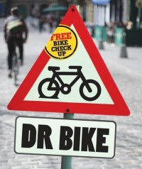
Repairs include;
Pumping up tyres and puncture repair
Replacement of minor parts, brake/gear cables, brake blocks etc (if required)

Unfortunately we can’t replace major parts; gear mechanisms, Brake levers, wheels etc

The Dr Bike Workshop will take place at Girlington PS Bring bike to staff car park on Girlington Rd
Date: Monday May 20th 2024
Time: 8.30am bike drop off. Pick up 3 – 4pm

What to do if you would like a FREE Dr Bike Check:
- On the Dr Bike day bring your bike to school preferably with your parent/carer, to staff car park & explain any problems with your bike.
- Go to school and enjoy your day.
- At the end of school come and collect your bike. If there is a sheet attached this will detail any recommendations about any more mechanical work that needs to be carried out by a bike shop.
- Please note that JU:MP bike mechanics will be with the bikes until 4pm. Pick up time is between 3 – 4pm

Dr Bike will endeavour to get through as many of the bikes on the day as possible and places will be allocated on a first come first served basis.

