Triple A screening
for men with learning disabilities
Men aged 65 and over should have Triple A screening.
This is a one-off ultrasound examination.

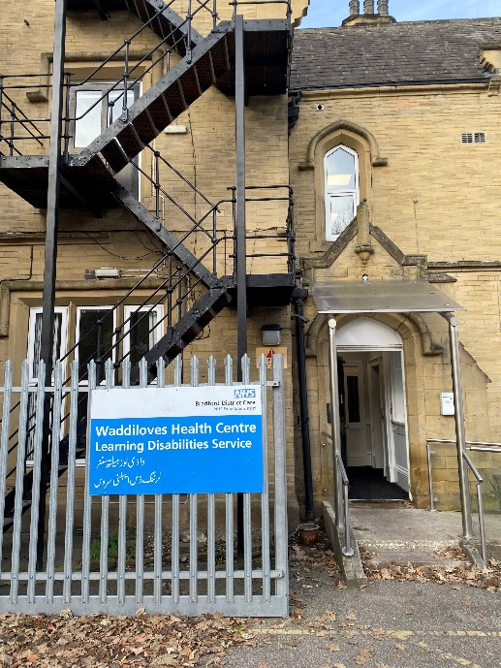
Waddiloves has a Triple A screening clinic for men with learning disabilities who have not attended Triple A screening before.

It is Wednesday 19th March 2025 between 1 – 3 pm.

Please email waddilovesclinic@bdct.nhs.uk
with the person’s NHS number if you or someone you support wants to attend.

More information is available at www.gov.uk/government/publications/abdominal-aortic-aneurysm-screening-easy-guide



