Story Board Care Home Case Study relating to the Telemedicine Service (TMS)
Please do not include any patient identifiable information and return to louise.keighley@bradford.nhs.uk by 30th August 2021
This does not need to be completed by a manager and if you prefer you can call Louise on 01274 237369 and she will populate the template whilst on the phone
Patient | Situation | Initial contact | Assessment | Advice/intervention | Outcome for patient
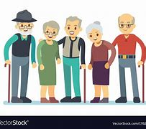 | 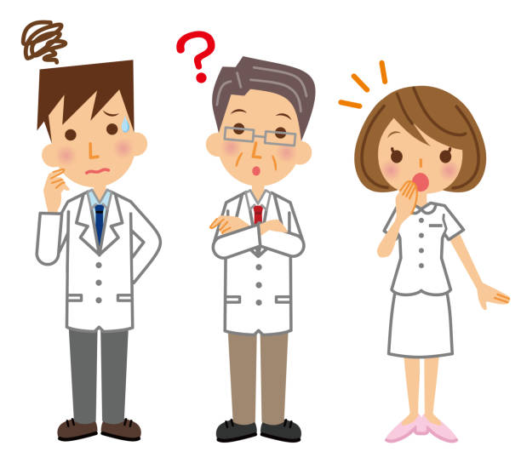 |  |  |  | 
Please provide brief information about the patient e.g. age, medical condition  Please do not include any patient identifiable information | Please provide brief  information about what happened that made you call the TMS | Please provide brief information about what happened when you called the TMS | Please provide brief information about what happened next (questions asked, assessments undertaken) | Please provide brief information about what advice/support/interventions were offered by the TMS | Please provide brief information of the outcome for the patient how did using the TMS benefit them

