RITA in Care Homes Project:
Supporting Information
(Reminiscence Interactive Therapy Activities)

Project Aim: Evaluate the role and impact of digital enabled interactive therapy (RITA) in enhancing the care and support for older people living mental health conditions and/or dementia who receive care from more than one care provider within the Bradford older people’s mental health and dementia care pathway - including DAU, Bracken Ward, Local Authority assessment bed facilities and care homes.

NOTE: RITA is not dependent upon Wi-Fi connectivity and can support care homes to improve resident wellbeing through meaningful activities and a platform which facilitates more person-centred care.

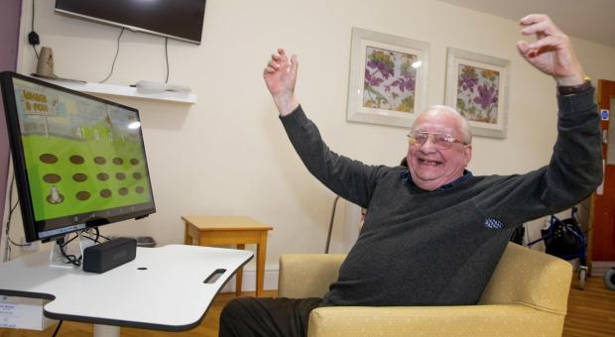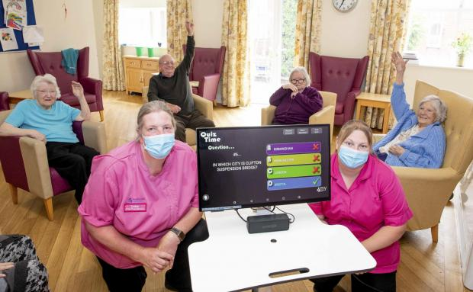

Testimonial from existing Care Sector user:
“I would recommend RITA to other CCG’s & Local Authorities as part of their strategic vision in reducing hospital admissions, for reducing 1-1’s and for reducing falls.”
Ruth Marshall – Clinical Quality Lead Nurse NHS North Tyneside CCG

Care home CQC report RITA feedback:
“The home was involved with a Reminiscence interactive Therapy/activities [RITA] project with the clinical commissioning group, where technology and reality orientation was used to stimulate people. A benefit was also as people were occupied there was evidence of a reduction in the number of falls.

.
RITA

Introduction
RITA stands for Reminiscence Interactive Therapy Activities and is an all-in-one touch Screen solution which offers digital reminiscence therapy which is a relatively new tool in the fields of nursing and healthcare; it encompasses the use of user-friendly interactive touch screen monitors and tablets to blend entertainment with therapy and to assist patients (particularly with memory impairments) in recalling and sharing events from their past through listening to music, watching news reports of significant historical events, listening to war-time speeches, playing games and karaoke, watching old TV shows, watching full length feature films and sporting events, producing digital life stories, viewing old maps and photographs, making video calls and watching films.

RITA Content
Full Length feature films, music searchable by genre, decade, artist, games, painting, old TV shows, iconic speeches, karaoke, Bingo, Life Story and Collage to record personal preferences, images of people and places, armchair exercises.
Go to www.myimprovementnetwork.com for more information on RITA.

Description
Problem Statement | Reduce challenging behaviour and providing a dementia friendly environment within hospital, community, mental health and care home/residential settings.  RITA provides opportunities to prevent social isolation within the care home environment; enables increased participation via person centred meaningful activity; frees up time for staff; increases connectedness and social interaction; supports daily routine/structure, and can help off-set environmental unfamiliarity.  RITA Aim: To create a person centred and dementia friendly care and support system with continuity of care at its heart - offering engaging, safe and therapeutic opportunities for residents allow for mental, psychological and physical wellbeing needs to be better met.

RITA Benefits | Care Home/System level:  - Reduce falls through stimulation, distraction and improved sleep awake cycles  - Reduce length of stay if conveyed to hospital setting – prevents of loss of function and stimulation  - Reduce hospital admissions  - Improve continuity of care, especially on transition  - Reduce high-cost care packages and expenditure  - Reduction in agitation and challenging behaviour  - Reduce the use of 1:1 specials  - Reduce transfers of care (including delayed transfer)  - Promote interaction with staff and family/friends  - Promote discussion and interactivity through the reminiscence system  Individual level:  - Calms and stimulates  - Reduce isolation, agitation and challenging behaviour through distraction  - Potential to reduce the use of anti-psychotic meds  - Shared individual experiences with staff and others  - Aide memoire to previous and current life  - Improve staff knowledge of patients in their care

Commissioning Priority Alignment | RITA can support our partners across pour placed based system to establish a more proactive approach to personalised care and support for older adults residing in care homes; support enhanced quality of life for individuals.  There is potential for RITA to facilitate a reduction in hospital admissions and a reduction in need for higher cost care packages.

Anticipated Impact | - Those diagnosed with dementia and their carers and families are able to receive person-centred care and support which is flexible with services able to respond to an individual’s needs rather than expect people to adapt to what exists already.  - Raising dementia awareness and understanding for staff and carers.  - Enabling access to assistive technology and / or equipment and making adaptations to the environment to maintain or improve a person’s independence, safety and wellbeing.  - Enabling access to cognitive stimulation programmes, such as teaching and practising memory strategies, which can improve both cognitive function and quality of life.  - People with dementia, their families and carers, receive person-centred care and support that adapts as the needs of an individual increases. Especially important when this is combined with physical illness, familial isolation and unfamiliar surroundings. (I.e., Hospitals)  - Reduction in the percentage of people with a diagnosis of dementia prescribed antipsychotic medications and a reduction in duration of treatment.  - To improve outcomes for people living with dementia and their carers.  - To improve emotional well-being for older people by reducing loneliness and social isolation with earlier intervention and community resilience.  - Further develop/enhance ‘Dementia Friendly Communities’ within care homes and across our place-based system.

Example RITA Features:
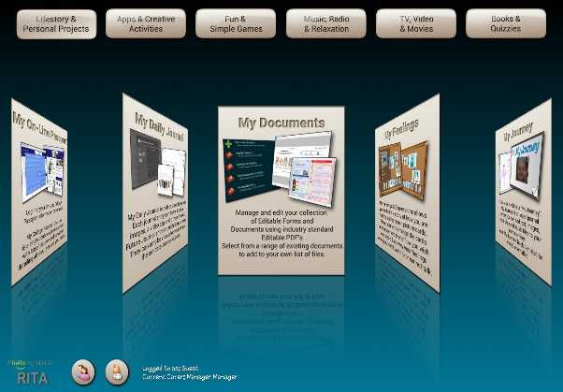
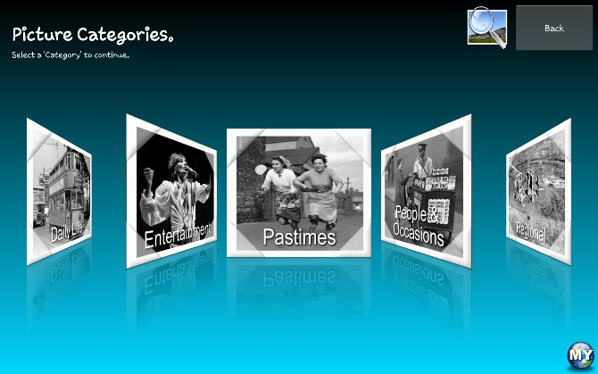

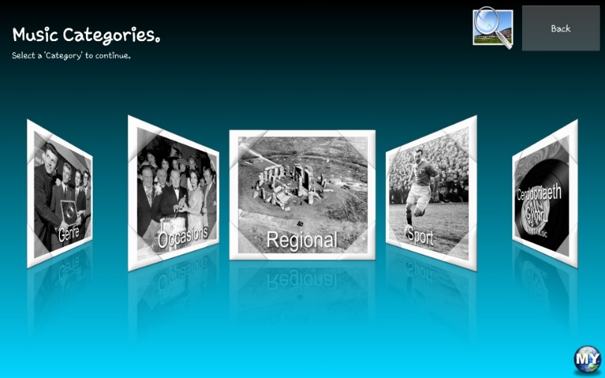
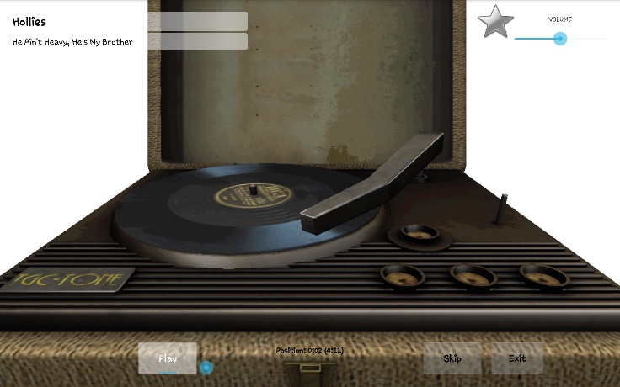

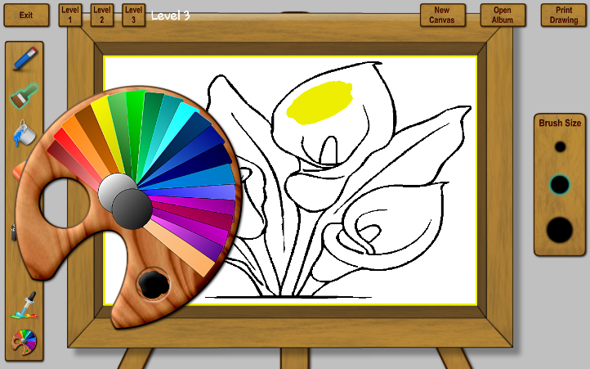

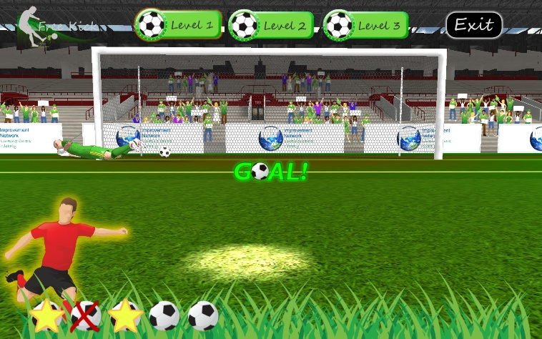

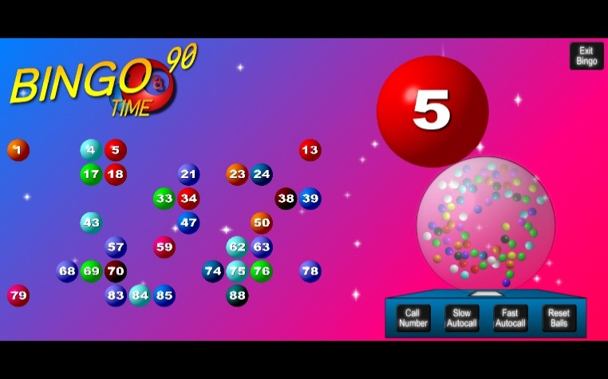

Act as One
Contact details:

Airedale NHS Foundation Trust
Skipton Road, Keighley, West Yorkshire, BD20 6TD
www.airedale-trust.nhs.uk

