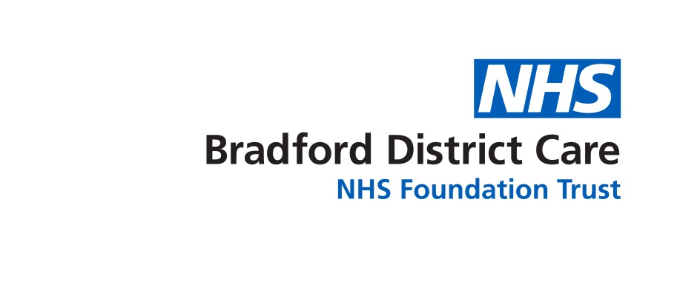

Marilou Armada – EOL facilitator for BDCT would like to offer CARE STAFF in residential care homes and domiciliary care the opportunity to attend FREE one 3hr - session as below.

What: Palliative care, ReSPECT conversation
End of Life

When: 13th or 20th or 27th July 2023
9-12pm or 1-4pm

Where: New Mill, Saltaire
Victoria Road, Bradford BD18 3LD

Spaces are limited-first come first served basis
To book a place, please DIRECTLY email marilou.armada@bdct.nhs.uk

PROGRAMME

09:00 - 09:10 Introduction and housekeeping
(13:00-13:10)

09:10 – 10:15 ReSPECT conversation
(13:10-14:15) Who can help?

10:15 - 10:30 break
(14:15-14:30)

10:30 – 12:00 Care of the dying
(14:30-16:00) Comfort and dignity plan
What matters now?

